Mental Health Response Advisory Committee (MHRAC)
Meeting Minutes
October 17, 2023
Via Zoom

Board Members in Attendance
Rachel Biggs Albuquerque Health Care for the Homeless
Commander Dietzel Crisis Intervention Division
Chief E. Jaramillo Albuquerque Fire Rescue
Mariela Angel-Ruiz / Jeff Bustamante Albuquerque Community Services
Paula Burton Peer Representative
David Ley New Mexico Solutions
Wendy Linebrink-Allison NMCAL
Betty Whiton NAMI
Gilbert Ramirez Family & Community Services
Robert Salazar NAMI Representative

Introduction to MHRAC
The Mental Health Response Advisory Committee (MHRAC) was created by the Court Approved Settlement Agreement (CASA). We’ve been around since day one and have a focus on three areas, resources, and resources being available to access different things within the city that APD and first responders can use as it impacts homelessness and mental health issues. We are also involved in training and policy. Training is one of those things we made a tremendous impact on. Policies are one of the things where the MHRAC is involved with assisting in writing, approving, and recommending policy as it relates again to the narrow focus; we think narrow, but sometimes it gets pretty wide-focused on how law enforcement interacts with those experiencing homelessness and those experiencing a mental health crisis.

Roll Call
There were ten (10) board members present, nine (9) MHRAC members, and one (1) representative.
Jeffrey Bustamante was a representative for Mariela Ruiz-Angel.

Welcome First-Time Guests
Aaron Nieto
City Outreach Associate

Approval of Meeting Minutes
1st Motion – David Ley
2nd Motion – Betty Whiton
Minutes from the September 2023 meeting were approved by the MHRAC Board Members.

Public Comment/Announcement
None

Nomination of New Board Members, if any, Rachel/Maxwell
Dr. Duranceaux was nominated as an MHRAC Board Member. David Ley motioned to reappoint Dr. Nicole Duranceaux to be an MHRAC Board Member and Rachel seconded the motion.

Fathom Meeting AI Summary:
- Joseph discussed the City of Albuquerque's initiative to address affordable housing through land use and financial support. Joseph mentioned the challenges and the limited options available to tackle the issue.
- Joseph discussed the housing crisis in Albuquerque, highlighting the lack of affordable housing and the increasing number of homeless individuals. He also mentioned the city's efforts to address the issue through various programs, funding, and the development of new housing projects.
- Joseph discussed various initiatives and challenges related to affordable housing, including negotiations for a new hotel, conversion of commercial properties into affordable units, difficulties in obtaining materials, and high labor costs. He also mentioned efforts to enforce tenant protections, rehab dilapidated units, and provide resources such as rental assistance and addiction prevention programs.
- Joseph discussed the challenges faced by community behavioral health agencies in providing housing for patients with ongoing case management requirements and criminal histories. He emphasized the need for developments that offer permanent housing with onsite 24-hour care and services to ensure successful outcomes for vulnerable individuals.
- David, Joseph, and Rachel discussed the challenges of affordable housing and the limited availability of vouchers. They also highlighted the need for more units and the difficulties faced by individuals with criminal records in finding housing.
- Joseph discussed the need for more funding for housing initiatives, specifically mentioning the Housing Trust Fund and the goal of creating 5,000 affordable units. He emphasized the challenges of meeting the demand and the importance of finding additional resources to address the issue.
- Rachel, Gilbert, Wendy, and Joseph discussed legislation related to recovery housing and the need for support and funding. They also talked about the importance of spreading affordable housing units across the city and incorporating on-site peer support for behavioral issues in these housing developments.
- Wendy, Joseph, Rachel, Gilbert, David, and Nicole discussed the importance of providing support systems and funding for housing individuals with mental health concerns.
- Rachel, David, and Nicole discussed the reappointment of Nicole to the committee.
- Jeffery provided updates on the growth and staffing changes within the Violence Prevention and Intervention department at ACS. They discussed the increase in team members, expansion to new schools, and efforts to meet the high call volumes during the summer and fall seasons. Jeffery, Jodie, Rachel, and Dr.Naru discussed updates on various programs and initiatives.
- Dr. Naru talked about the occupancy and services provided at Gateway, the need for more case managers and housing navigators, and the success of the Family Housing Navigation Center in transitioning individuals and families from homelessness to housing.
- Dr. Naru provided updates on the progress of construction and plans for an emergency winter shelter. Rachel asked questions about the differences between the women's shelter and the emergency shelter, and Dr. Naru clarified the distinctions.
- Commander Dietzel thanked the team for their work at Balloon Fiesta and warned about scams targeting people claiming to be from APD
- Nicole discussed revising the BSS, SOP, and other SOPs with input from stakeholders and the MHRAC co-chairs. She mentioned that a draft would be shared for feedback within 30 days. Commander Dietzel expressed the need for assistance with cases related to homelessness and medication, and David and Jodie offered potential solutions and resources to help address the issue.
- The group discussed various topics including the arrival of new responders, concerns about staffing and potential gaps in services, updates on training and vacancies, appreciation for a crisis clinician, and the existence of casework-type positions within the organization. They acknowledged the need for support and expressed gratitude for leadership and the opportunity to help the community
- Rachel, Commander Dietzel, David, and Andrew discussed combining subcommittees, updating the bylaws, and creating an ordinance for MHRAC
City’s Housing Forward Program Joseph Montoya and Aaron Nieto
- The City of Albuquerque started an initiative about two years ago in terms of creating what is called Housing Forward.
- The City has two levers to push; one is land issues, how to make it easier to be able to get land use. The other issue is financial support.
- The overall goal of the City Housing Forward Program is to ensure that everyone in Albuquerque has a place to live that they can afford. That is a very big goal to have because right now over 75% of the population can’t afford a medium-priced home.
- We roughly have over 30,000 units of housing to become what we call market equilibrium, meaning that there’s a relationship between supply and demand.
- In just three years, rent has increased by over 20%. The relationship between rental or mortgage and income is completely off balance.
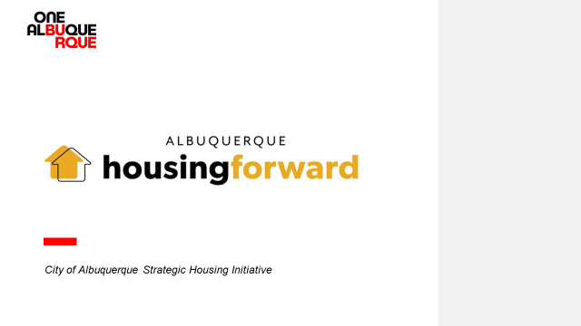

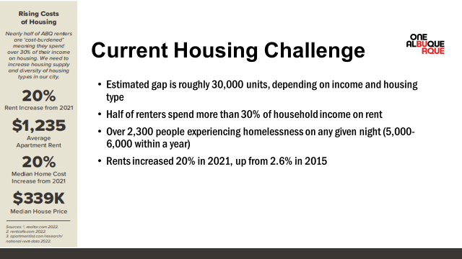

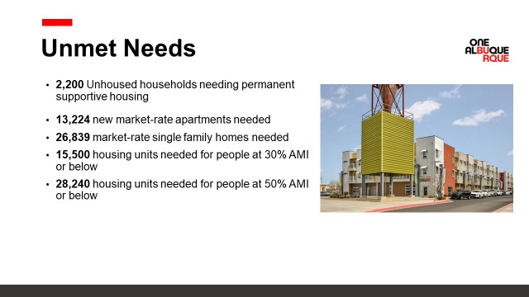

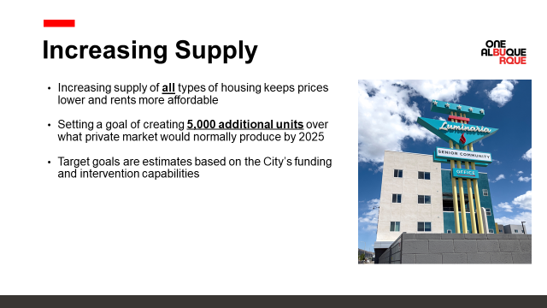

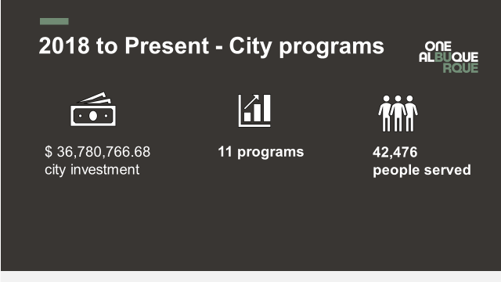

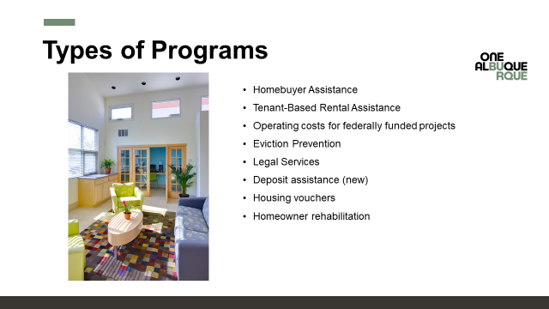

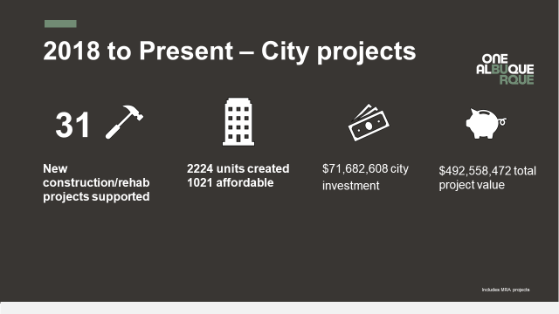

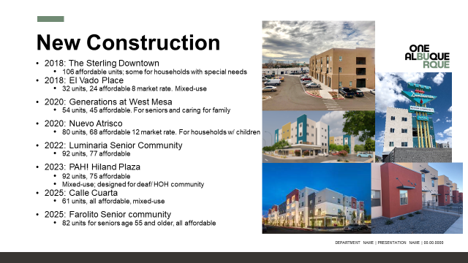

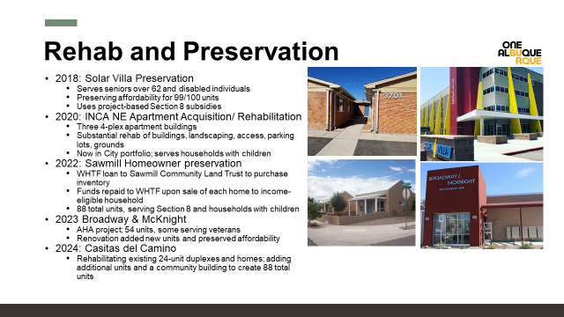

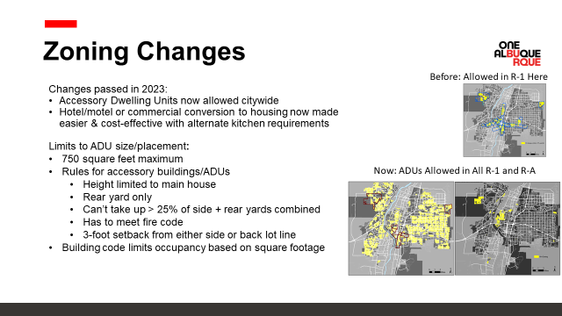

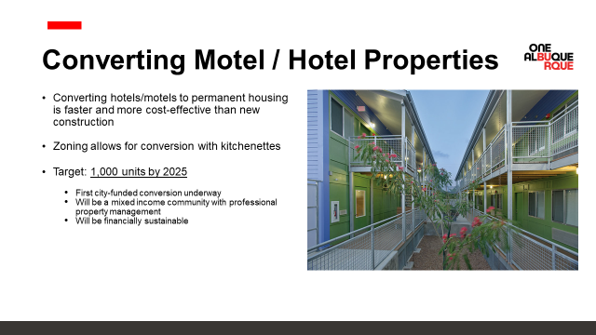

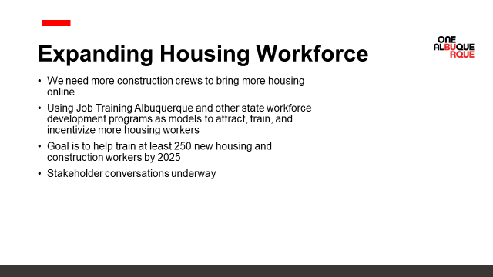
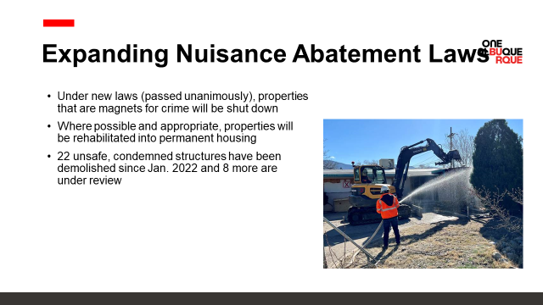

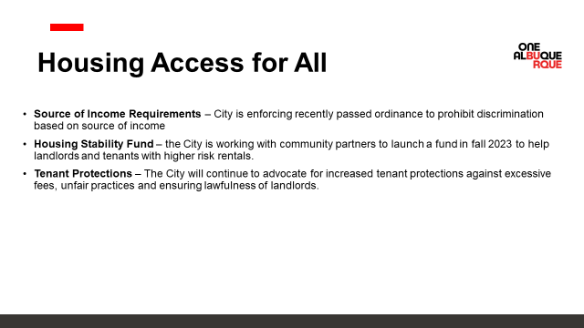

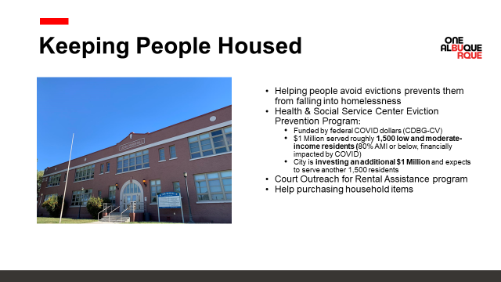

Albuquerque Community Safety (ACS) Update, Jeffrey Bustamante, Deputy Director
- We have gone 24/7 and we have coverage throughout the day.
- We structure to make sure that we are putting the staffing to the volume. We have already made some adjustments and continue to do so to make sure that we’re meeting the need.
- As things evolve, we monitor call volume and the nature of the calls so we can have the right teams on.
- Jodie Jensen has joined the ACS team as the Homeless Liaison Administrator. She will be supporting the street outreach.
- We still have a substantial amount of behavioral health calls and that continues to be the majority, but some months we have a plurality of those homeless calls.
- We have a series of responders that are completing OJT and we will have an academy before end-of-year which should be one of our larger academies. We’ve hired in just about every position in violence prevention; it has grown from 2 to 5. Our Opioid Education and Prevention Team has grown from 1 to 2. Our CORE has gone from 2 to 5 and we just interviewed for a 6th person. Our school-based violence intervention is our one individual out at West Mesa but we are going to be expanding to another school and hiring 3 more individuals. Every single one of our programs has grown.
- As far as growth in general, it has been a year of growth and refinement for ACS.
- We’re doing quality assurance on everything.

Gibson Health Hub, Family & Community Services Update, Dr. Azka Naru, Gateway Manager
- Gateway is open and currently receiving unaccompanied women. We have a total of 50 beds available in the facility and we are at the Census of 49. Of the guests that have come in, 42-45% have been coming in with minimum documents for housing.
- Only 15% have come in with a case manager.
- We are working closely with our community partners.
- We are working closely with community partners to bulk up our Engagement Center.
- We have Workforce Solutions on board with us so they have been a very helpful partner over at the Family Housing Navigation Center. They assist with job readiness, drafting resumes, and opening up opportunities for clients. They work one-on-one with the women that are at Gateway.
- I have identified that 78.5% have health insurance
- The Family Housing Navigation Center housed over 1100 individuals and 638 children have been moved from homelessness to housing.
- Over half of the supportive housing vouchers have been city-funded.
- We are making progress towards construction and hoping to go live sometime next year; the tentative date is October 2024.
- The Sobering Center construction is underway and expected to go live by the 10th of June 2024

CIU, APD, and BSS Report and Update, Commander Dietzel, Dr. Duranceaux, Sgt. Tinney
- We just finished up Balloon Fiesta. It was tough on those who worked due to lack of sleep. It consists of very early morning and then night working hours. The CIU was there every single day.
- APD is seeing a ton of scams right now. People get a text message or a phone call claiming to be a police officer. They are saying they are APD and you have a warrant and the only way to fix that warrant is to send a ridiculous amount of money to some address
- Dr. Duranceaux has been working on revising the Behavioral Sciences Section (BSS) SOP for APD and a couple of other SOPs that will be coming down the pike shortly after. We want the stakeholder's and the community's input. MHRAC Co-chairs, Rachel and David, were gracious in helping in that process and giving wonderful feedback.
- The biggest comment from officers was to make it shorter so that is still being worked on.
- We were at 503 referrals last month from field officers. I was able to assign 113. At that time ACS was helping the CIU and 185 went to them. ACS is no longer able to accept referrals.
- Our CIU Follow-up detectives are focused on people who are presenting a danger to the public.
- We have about 175 cases that we have not been able to help people on.
- Officers send reports of someone experiencing homelessness and needing help getting back on medication, but we do not have a COAST, so we don’t know how to help these people.

MHRAC Sub-Committee Report and Updates
Training Sub-Committee, David Ley
- We are reviewing some training plans and updating
- One thing that we have put to the committee was identifying any additional areas of training that may be appropriate for us to review
- We have proposed and started to explore the possibility of combining the Training and Information Sharing Subcommittees. The MHRAC and the sub-committees have accomplished so much which in turn puts us more in a maintenance phase.

Inforshare/Resources/Policy Sub-committee, Commander Dietzel
- No sub-committee meeting at the end of September due to combining both of the sub-committee meetings, effective October 30, 2023.

MHRAC Final Discussion, Rachel Biggs
- We are combining the Infoshare and Training Sub-committees into one sub-committee. If anyone is interested in being a part of the new sub-committee please let me, David Ley, or Brenda know and one of us will send you an invite.
- We need to update the bylaws
- It is time for MHRAC to look at an ordinance just like the Civilian Police Oversight Agency (CPOA) and the Community Policing Council (CPC) so we are codified.

The meeting was Transcribed by Fathom and revised by Brenda Vigil-Gallegos. Board Members, for a copy of the “unrevised” transcription, email bvigil-gallegos@cabq.gov

Next meeting: November 21, 2023

